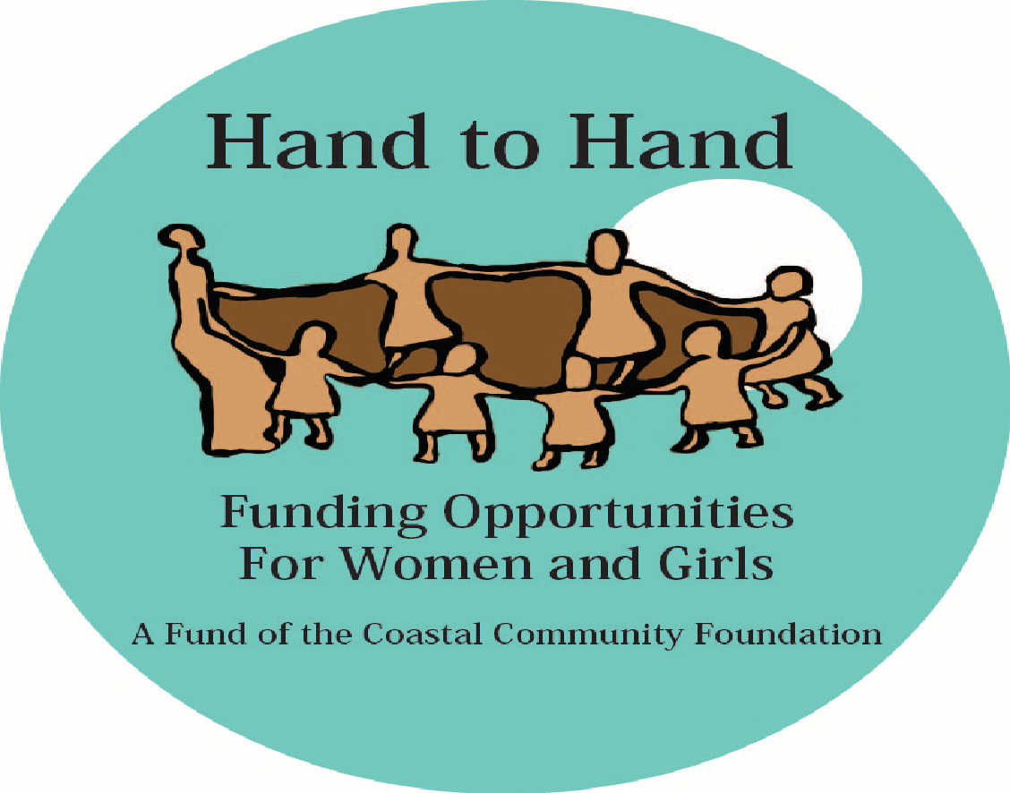
2024 Grant Guidelines
Deadline: Monday, July 1st, 2024

Mission
Hand to Hand makes an impact on the lives of women and girls in San Diego County by directing resources to programs that empower change and self-sufficiency.

Grant Funding
Grant funds may support new programs or services or expand and improve current programs. All Grant funds must be used in support of women and girls only.
Hand to Hand grant requests must fulfill our mission and must include one or more of these focus areas:
- education and job training for women | - programs for women re-entering the work force
- mentoring programs for women and/or girls | - health and wellness programs for women and girls
Grant range: $3,000 - $10,000

Eligibility Requirements
Grant applicants must meet the following criteria:
- Must be a 501(c) 3 organization in existence for at least two years.
- Preference will be given to organizations with budgets UNDER $2 million. Hand to Hand will NOT consider any grants from organizations with branch/local chapter budgets over $10 million.
- Grants are not made to individuals, for special events, endowments, religious or political advocacy, research, capital campaigns or for programs outside of San Diego County.
- Programs and services must align with Hand to Hand’s mission and one or more focus areas.
- Grant funds will be awarded in November 2024. No funding will be provided to programs that are completed before November 2024.
- The organization must be willing to host a scheduled site visit for evaluation of the proposal.
- If funded, organizations must submit an electronic report specified by Hand to Hand. The report must be submitted within a specific timeline and the organization must be willing to provide feedback, stories and pictures which can be used in publications and on our website.

How to Apply:
Note: Only online applications will be accepted.
- Complete the application on the Coastal Community Foundation website https://coastalfoundation.org/grants/.
Application available May 6th, 2024 and due July 1, 2024.
- Submit the following items in separate documents to grants@coastalfoundation.org :
1. current organization budget (income and expenses)
2. current Profit and Loss statement,
3. most recent 990 (pdf format)
- Hand to Hand is a fund at Coastal Community Foundation. Organizations that have not applied to or received a grant from Coastal Community Foundation within the past two years must submit an IRS tax-exempt letter. A copy of the IRS tax-exempt letter may be emailed to grants@coastalfoundation.org

